City of Darebin

Qualifications
Educational Qualifications relate to education outside of primary and secondary school and are one of the most important indicators of socio-economic status. With other data sources, such as Employment Status, Income and Occupation, the City of Darebin's Educational Qualifications help to evaluate the economic opportunities and socio-economic status of the area and identify skill gaps in the labour market.
Learn more about planning education provision here.
Highest qualification achieved
City of Darebin - Persons aged 15+ (Usual residence) | 2021 |  |  | 2011 |  |  | Change
Qualification level | Number | % | Greater Melbourne % | Number | % | Greater Melbourne % | 2011 to 2021
Bachelor or Higher degree | 50,038 | 39.6 | 32.8 | 31,537 | 27.6 | 23.6 | +18,501
Advanced Diploma or Diploma | 11,098 | 8.8 | 10.0 | 8,861 | 7.8 | 8.8 | +2,237
Vocational | 14,586 | 11.6 | 14.8 | 13,160 | 11.5 | 15.0 | +1,426
No qualification | 41,821 | 33.1 | 35.2 | 48,036 | 42.1 | 42.4 | -6,215
Not stated | 8,673 | 6.9 | 7.2 | 12,637 | 11.1 | 10.3 | -3,964
Total persons aged 15+ | 126,216 | 100.0 | 100.0 | 114,231 | 100.0 | 100.0 | +11,985
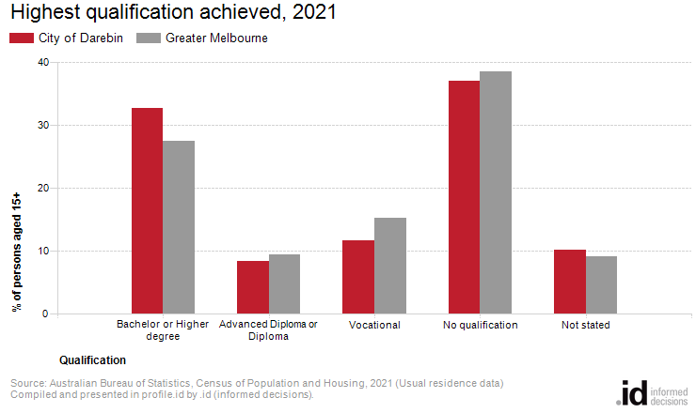
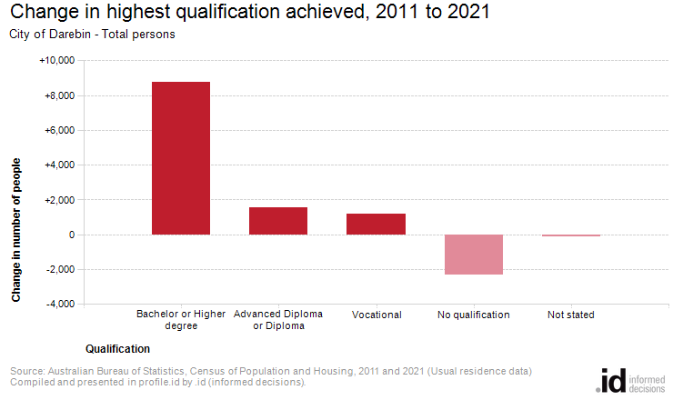
Analysis of the qualifications of the population in the City of Darebin in 2021 compared to Greater Melbourne shows that there was a higher proportion of people holding formal qualifications (Bachelor or higher degree; Advanced Diploma or Diploma; or Vocational qualifications), and a lower proportion of people with no formal qualifications.
Overall, 52.7% of the population aged 15 and over held educational qualifications, and 37.1% had no qualifications, compared with 52.2% and 38.6% respectively for Greater Melbourne.
The major differences between qualifications held by the population of the City of Darebin and Greater Melbourne were:
- A larger percentage of persons with Bachelor or Higher degrees (32.7% compared to 27.5%)
- A smaller percentage of persons with Vocational qualifications (11.6% compared to 15.3%)
- A smaller percentage of persons with No qualifications (37.1% compared to 38.6%)
- A smaller percentage of persons with Advanced Diploma or Diplomas (8.4% compared to 9.5%)
The largest changes in the qualifications of the population in the City of Darebin between 2011 and 2021 were in those with:
- Bachelor or Higher degrees (+8,745 persons)
- No qualifications (-2,307 persons)
- Advanced Diploma or Diplomas (+1,534 persons)
- Vocational qualifications (+1,181 persons)

