City of Darebin

Occupation of employment
Fairfield's occupation statistics quantify the occupations in which the residents work (which may be within the residing area or elsewhere). This will be influenced by the economic base and employment opportunities available in the area, education levels, and the working and social aspirations of the population. When viewed with other indicators, such as Educational Qualifications and Individual Income, Occupation is a key measure for evaluating Fairfield's socio-economic status and skill base.
Occupation of employment
Fairfield - Employed persons (Usual residence) | 2021 |  |  | 2011 |  |  | Change
Occupation | Number | % | City of Darebin % | Number | % | City of Darebin % | 2011 to 2021
Managers | 534 | 15.9 | 14.1 | 388 | 13.5 | 11.4 | +145
Professionals | 1,410 | 42.0 | 34.3 | 1,040 | 36.1 | 28.7 | +369
Technicians and Trades Workers | 274 | 8.2 | 10.3 | 291 | 10.1 | 12.0 | -18
Community and Personal Service Workers | 289 | 8.6 | 10.1 | 236 | 8.2 | 9.3 | +52
Clerical and Administrative Workers | 382 | 11.4 | 11.9 | 428 | 14.9 | 14.7 | -47
Sales Workers | 213 | 6.3 | 7.1 | 189 | 6.6 | 8.7 | +23
Machinery Operators And Drivers | 67 | 2.0 | 3.9 | 85 | 3.0 | 4.9 | -19
Labourers | 143 | 4.3 | 6.5 | 133 | 4.6 | 7.8 | +9
Not stated or inadequately described | 50 | 1.5 | 1.8 | 85 | 3.0 | 2.5 | -36
Total employed persons aged 15+ | 3,357 | 100.0 | 100.0 | 2,880 | 100.0 | 100.0 | +476
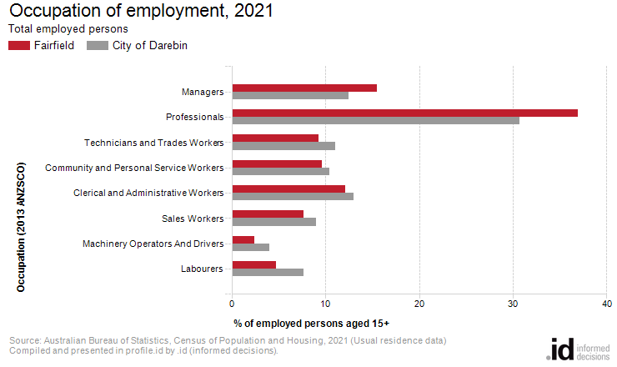
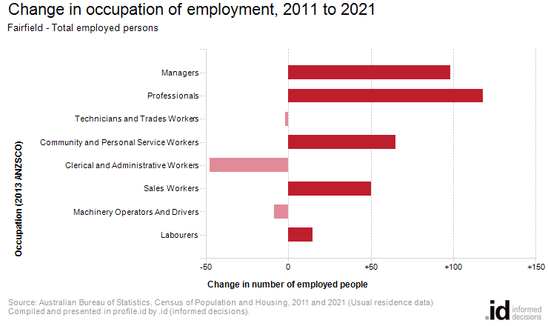
An analysis of the jobs held by the resident population in Fairfield in 2021 shows the three most popular occupations were:
- Professionals (1,158 people or 36.9%)
- Managers (487 people or 15.5%)
- Clerical and Administrative Workers (381 people or 12.1%)
In combination these three occupations accounted for 2,026 people in total or 64.6% of the employed resident population.
In comparison, the City of Darebin employed 30.7% in Professionals; 12.5% in Managers; and 13.0% in Clerical and Administrative Workers.
The major differences between the jobs held by the population of Fairfield and the City of Darebin were:
- A larger percentage of persons employed as Professionals (36.9% compared to 30.7%)
- A larger percentage of persons employed as Managers (15.5% compared to 12.5%)
- A smaller percentage of persons employed as Labourers (4.7% compared to 7.7%)
- A smaller percentage of persons employed as Technicians and Trades Workers (9.2% compared to 11.0%)
The number of employed people in Fairfield increased by 256 between 2011 and 2021.
The largest changes in the occupations of residents between 2011 and 2021 in Fairfield were for those employed as:
- Professionals (+118 persons)
- Managers (+98 persons)
- Community and Personal Service Workers (+65 persons)
- Sales Workers (+50 persons)

