Cessnock City Council

Household income
Households form the common 'economic unit' in our society. Bellbird - Bellbird Heights - Bellbird North's Household Income is one of the most important indicators of socio-economic status. With other data sources, such as Qualifications and Occupation, it helps to reveal the economic opportunities and socio-economic status of Bellbird - Bellbird Heights - Bellbird North. It is important to note that income data is not necessarily a measure of wealth. For example, if an area has a large number of retirees this will produce a higher proportion of households with low income but the retirees may have large capital wealth. For this reason, household income should be viewed in conjunction with Age and Household Composition.
The incomes presented on this page are for the latest Census year only. For comparison of incomes over time, go to Household Income Quartiles.
Learn more about the characteristics of low-income households here.
Weekly household income
Bellbird - Bellbird Heights - Bellbird North - Total households (Enumerated) | 2021
Weekly income | Number | % | Cessnock City %
Neg/Nil Income | 12 | 1.1 | 1.7
$1 - $149 | 5 | 0.4 | 0.6
$150 - $299 | 15 | 1.3 | 1.1
$300 - $399 | 30 | 2.6 | 2.4
$400 - $499 | 82 | 7.2 | 6.7
$500 - $649 | 54 | 4.8 | 4.8
$650 - $799 | 90 | 7.9 | 7.2
$800 - $999 | 81 | 7.1 | 7.1
$1,000 - $1,249 | 108 | 9.5 | 7.5
$1,250 - $1,499 | 78 | 6.9 | 7.5
$1,500 - $1,749 | 72 | 6.3 | 5.9
$1,750 - $1,999 | 66 | 5.8 | 5.5
$2,000 - $2,499 | 120 | 10.6 | 11.4
$2,500 - $2,999 | 87 | 7.7 | 7.4
$3,000 - $3,499 | 54 | 4.8 | 5.6
$3,500 - $3,999 | 26 | 2.3 | 3.2
$4,000 - $4,499 | 12 | 1.1 | 1.7
$4,500 - $4,999 | 33 | 2.9 | 2.4
$5,000 - $5,999 | 18 | 1.6 | 1.6
$6,000 - $7,999 | 14 | 1.2 | 1.1
$8,000 or more | 7 | 0.6 | 0.5
Not stated | 70 | 6.2 | 7.3
Total households | 1,134 | 100.0 | 100.0
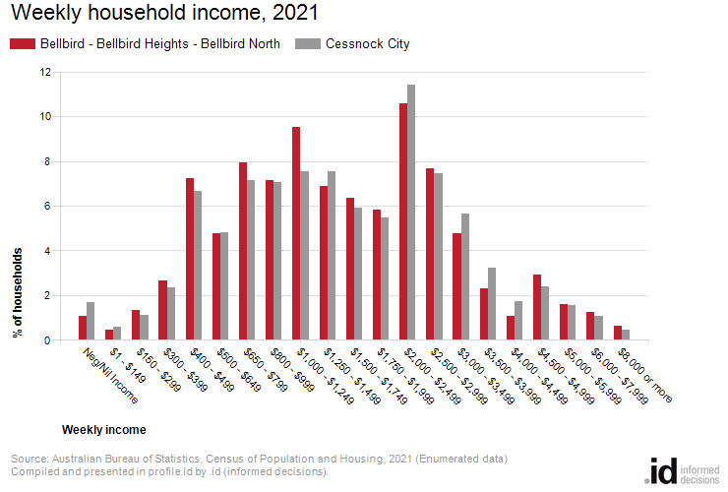
Analysis of household income levels in Bellbird - Bellbird Heights - Bellbird North in 2021 compared to Cessnock City shows that there was a smaller proportion of high income households (those earning $3,000 per week or more) and a higher proportion of low income households (those earning less than $800 per week).
Overall, 14.4622% of the households earned a high income and 25.3968% were low income households, compared with 16.0347% and 24.3677% respectively for Cessnock City.
The major differences between the household incomes of Bellbird - Bellbird Heights - Bellbird North and Cessnock City were:
- A larger percentage of households who earned $1,000 - $1,249 (9.5% compared to 7.5%)
- A smaller percentage of households who earned Not stated (6.2% compared to 7.3%)

