Cairns Regional Council

Occupation of employment
Cairns's occupation statistics quantify the occupations in which the residents work (which may be within the residing area or elsewhere). This will be influenced by the economic base and employment opportunities available in the area, education levels, and the working and social aspirations of the population. When viewed with other indicators, such as Educational Qualifications and Individual Income, Occupation is a key measure for evaluating Cairns's socio-economic status and skill base.
Occupation of employment
Cairns - Employed persons (Usual residence) | 2021 |  |  | 2016 |  |  | Change
Occupation | Number | % | Regional QLD % | Number | % | Regional QLD % | 2016 to 2021
Managers | 8,814 | 11.1 | 12.4 | 7,929 | 11.0 | 12.4 | +885
Professionals | 16,235 | 20.4 | 18.0 | 13,936 | 19.2 | 16.7 | +2,299
Technicians and Trades Workers | 11,931 | 15.0 | 15.1 | 10,826 | 15.0 | 15.7 | +1,105
Community and Personal Service Workers | 11,887 | 14.9 | 13.0 | 9,951 | 13.7 | 11.8 | +1,936
Clerical and Administrative Workers | 9,531 | 12.0 | 11.8 | 9,545 | 13.2 | 12.5 | -14
Sales Workers | 7,525 | 9.4 | 9.1 | 7,767 | 10.7 | 10.2 | -242
Machinery Operators And Drivers | 4,478 | 5.6 | 7.3 | 4,087 | 5.6 | 7.6 | +391
Labourers | 7,874 | 9.9 | 11.2 | 7,138 | 9.9 | 11.6 | +736
Not stated or inadequately described | 1,372 | 1.7 | 2.0 | 1,232 | 1.7 | 1.6 | +140
Total employed persons aged 15+ | 79,649 | 100.0 | 100.0 | 72,411 | 100.0 | 100.0 | +7,238
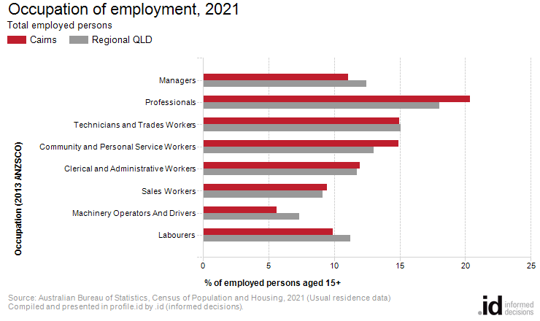
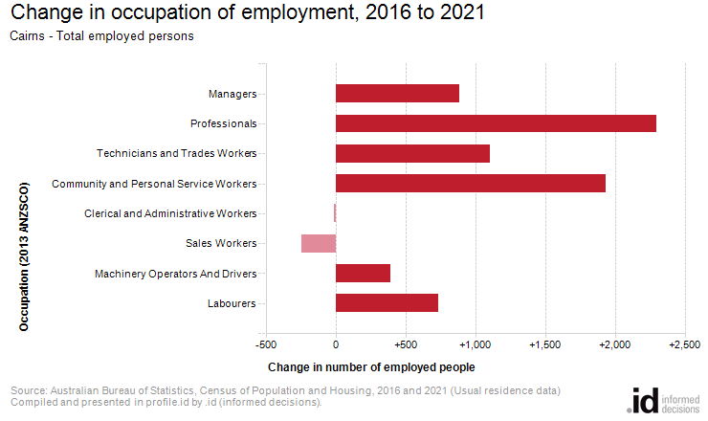
An analysis of the jobs held by the resident population in Cairns in 2021 shows the three most popular occupations were:
- Professionals (16,235 people or 20.4%)
- Technicians and Trades Workers (11,931 people or 15.0%)
- Community and Personal Service Workers (11,887 people or 14.9%)
In combination these three occupations accounted for 40,053 people in total or 50.3% of the employed resident population.
In comparison, Regional QLD employed 18.0% in Professionals; 15.1% in Technicians and Trades Workers; and 13.0% in Community and Personal Service Workers.
The major differences between the jobs held by the population of Cairns and Regional QLD were:
- A larger percentage of persons employed as Professionals (20.4% compared to 18.0%)
- A larger percentage of persons employed as Community and Personal Service Workers (14.9% compared to 13.0%)
- A smaller percentage of persons employed as Machinery Operators And Drivers (5.6% compared to 7.3%)
- A smaller percentage of persons employed as Managers (11.1% compared to 12.4%)
The number of employed people in Cairns increased by 7,238 between 2016 and 2021.
The largest changes in the occupations of residents between 2016 and 2021 in Cairns were for those employed as:
- Professionals (+2,299 persons)
- Community and Personal Service Workers (+1,936 persons)
- Technicians and Trades Workers (+1,105 persons)
- Managers (+885 persons)

