Cairns Regional Council

Industry sector of employment
Cairns's industry statistics identify the industry sectors in which the residents work (which may be within the residing area or elsewhere). This will be influenced by the skill base and socio-economic status of the residents as well as the industries and employment opportunities present in the region.
When viewed in conjunction with Residents Place of Work data and Method of Travel to Work, industry sector statistics provide insights into the relationship between the economic and residential role of the area.
Industry sector of employment
Cairns - Employed persons (Usual residence) | 2021 |  |  | 2016 |  |  | Change
Industry sector | Number | % | Regional QLD % | Number | % | Regional QLD % | 2016 to 2021
Agriculture, Forestry and Fishing | 1,262 | 1.6 | 4.3 | 1,176 | 1.6 | 4.7 | +86
Mining | 1,368 | 1.7 | 3.5 | 1,045 | 1.4 | 3.5 | +323
Manufacturing | 2,877 | 3.6 | 5.4 | 2,698 | 3.7 | 5.5 | +179
Electricity, Gas, Water and Waste Services | 863 | 1.1 | 1.2 | 666 | 0.9 | 1.1 | +197
Construction | 6,903 | 8.7 | 9.6 | 5,899 | 8.1 | 9.3 | +1,004
Wholesale trade | 1,660 | 2.1 | 2.1 | 1,706 | 2.4 | 2.3 | -46
Retail Trade | 7,706 | 9.7 | 9.6 | 7,685 | 10.6 | 10.3 | +21
Accommodation and Food Services | 7,908 | 9.9 | 8.0 | 7,268 | 10.0 | 8.2 | +640
Transport, Postal and Warehousing | 4,487 | 5.6 | 4.1 | 4,590 | 6.3 | 4.5 | -103
Information Media and Telecommunications | 454 | 0.6 | 0.8 | 585 | 0.8 | 1.0 | -131
Financial and Insurance Services | 1,038 | 1.3 | 1.8 | 1,087 | 1.5 | 1.9 | -49
Rental, Hiring and Real Estate Services | 1,351 | 1.7 | 1.7 | 1,458 | 2.0 | 2.0 | -107
Professional, Scientific and Technical Services | 3,745 | 4.7 | 4.8 | 3,387 | 4.7 | 4.6 | +358
Administrative and Support Services | 2,888 | 3.6 | 3.3 | 3,098 | 4.3 | 3.5 | -210
Public Administration and Safety | 5,852 | 7.3 | 5.6 | 5,794 | 8.0 | 6.0 | +58
Education and Training | 7,056 | 8.9 | 8.7 | 6,500 | 9.0 | 8.8 | +556
Health Care and Social Assistance | 14,389 | 18.1 | 15.4 | 10,446 | 14.4 | 12.8 | +3,943
Arts and Recreation Services | 1,249 | 1.6 | 1.6 | 1,436 | 2.0 | 1.6 | -187
Other Services | 3,622 | 4.5 | 4.1 | 3,047 | 4.2 | 4.0 | +575
Inadequately described or not stated | 2,981 | 3.7 | 4.4 | 2,828 | 3.9 | 4.3 | +153
Total employed persons aged 15+ | 79,659 | 100.0 | 100.0 | 72,399 | 100.0 | 100.0 | +7,260
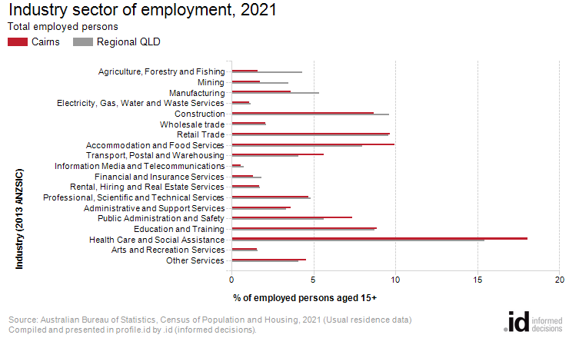
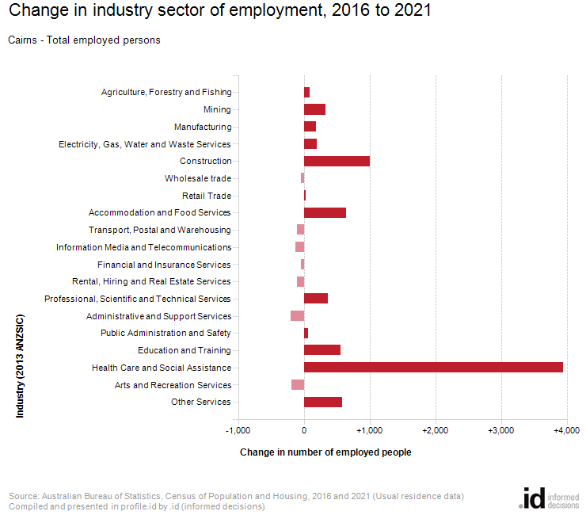
An analysis of the jobs held by the resident population in Cairns in 2021 shows the three most popular industry sectors were:
- Health Care and Social Assistance (14,389 people or 18.1%)
- Accommodation and Food Services (7,908 people or 9.9%)
- Retail Trade (7,706 people or 9.7%)
In combination, these three industries employed 30,003 people in total or 37.7% of the total employed resident population.
In comparison, Regional QLD employed 15.4% in Health Care and Social Assistance; 8.0% in Accommodation and Food Services; and 9.6% in Retail Trade.
The major differences between the jobs held by the population of Cairns and Regional QLD were:
- A larger percentage of persons employed in health care and social assistance (18.1% compared to 15.4%)
- A larger percentage of persons employed in accommodation and food services (9.9% compared to 8.0%)
- A smaller percentage of persons employed in agriculture, forestry and fishing (1.6% compared to 4.3%)
- A smaller percentage of persons employed in manufacturing (3.6% compared to 5.4%)
The number of employed people in Cairns increased by 7,260 between 2016 and 2021.
The largest changes in the jobs held by the resident population between 2016 and 2021 in Cairns were for those employed in:
- Health Care and Social Assistance (+3,943 persons)
- Construction (+1,004 persons)
- Accommodation and Food Services (+640 persons)
- Other Services (+575 persons)

