City of Brimbank

Religion
Sunshine West's religion statistics provide an indicator of cultural identity and ethnicity when observed in conjunction with other key variables. Religion data reveal the major concentrations of religions as well as revealing the proportion of people with no religious affiliation. There are a number of reasons for different religious compositions across areas including the country of birth and ethnic background of the population, the age of the population (belief in religion is generally stronger, the older the population) and changes in values and belief systems.
Sunshine West's religion statistics should be analysed in conjunction with other ethnicity statistics such as Country of Birth data and Language Spoken data to assist in identifying specific cultural and ethnic groups.
Please note: Due to changes in ABS rules around perturbation and additivity of data to protect the confidentiality of individuals, counts of individual religion groups and totals derived from them may differ slightly from those published by the ABS.
Religion - Summary
Sunshine West - Total persons (Usual residence) | 2021 |  |  | 2016 |  |  | Change
Religion totals | Number | % | City of Brimbank % | Number | % | City of Brimbank % | 2016 to 2021
Christian total | 8,444 | 45.5 | 48.3 | 9,205 | 49.5 | 51.9 | -761
Non Christian total | 4,618 | 24.9 | 23.0 | 4,553 | 24.5 | 22.3 | +65
Non-classifiable religious belief | 82 | 0.4 | 0.4 | 91 | 0.5 | 0.5 | -9
No Religion/secular beliefs | 4,123 | 22.2 | 21.1 | 3,340 | 18.0 | 16.9 | +783
Not stated | 1,291 | 7.0 | 7.1 | 1,393 | 7.5 | 8.4 | -102
Total Population | 18,558 | 100.0 | 100.0 | 18,582 | 100.0 | 100.0 | -24
Religion - Ranked by size
Sunshine West - Total persons (Usual residence) | 2021 |  |  | 2016 |  |  | Change
Religion | Number | % | City of Brimbank % | Number | % | City of Brimbank % | 2016 to 2021
Western (Roman) Catholic | 4,643 | 25.0 | 29.2 | 5,048 | 27.2 | 31.1 | -405
Buddhism | 2,183 | 11.8 | 11.1 | 2,278 | 12.3 | 10.8 | -95
Islam | 1,777 | 9.6 | 6.7 | 1,553 | 8.4 | 5.8 | +224
Greek Orthodox | 1,122 | 6.0 | 3.9 | 1,314 | 7.1 | 4.3 | -192
Christian,nfd | 700 | 3.8 | 3.8 | 0 | 0.0 | 3.5 | +700
Hinduism | 499 | 2.7 | 3.1 | 490 | 2.6 | 2.9 | +9
Baptist | 343 | 1.8 | 1.6 | 315 | 1.7 | 1.5 | +28
Anglican | 336 | 1.8 | 2.4 | 449 | 2.4 | 3.1 | -113
Macedonian Orthodox | 276 | 1.5 | 1.4 | 301 | 1.6 | 1.5 | -25
Pentecostal | 169 | 0.9 | 1.0 | 286 | 1.5 | 1.4 | -117
Uniting Church | 128 | 0.7 | 0.8 | 119 | 0.6 | 1.0 | +9
Other Oriental Orthodox | 121 | 0.7 | 0.4 | 110 | 0.6 | 0.4 | +11
Other Protestant | 120 | 0.6 | 0.5 | 89 | 0.5 | 0.5 | +31
Presbyterian and Reformed | 119 | 0.6 | 0.6 | 182 | 1.0 | 0.9 | -63
Jehova's Witnesses | 103 | 0.6 | 0.3 | 100 | 0.5 | 0.4 | +3
Sikhism | 100 | 0.5 | 1.8 | 190 | 1.0 | 2.6 | -90
Serbian Orthodox | 67 | 0.4 | 0.5 | 47 | 0.3 | 0.5 | +20
Coptic Orthodox | 41 | 0.2 | 0.4 | 33 | 0.2 | 0.4 | +8
Latter Day Saints (Mormons) | 34 | 0.2 | 0.3 | 44 | 0.2 | 0.3 | -10
Seventh Day Adventist | 28 | 0.2 | 0.2 | 35 | 0.2 | 0.2 | -7
Other Eastern Catholic | 25 | 0.1 | 0.4 | 25 | 0.1 | 0.2 | 0
Other Non-Christian Religions | 21 | 0.1 | 0.1 | 11 | 0.1 | 0.1 | +10
Lutheran | 19 | 0.1 | 0.2 | 33 | 0.2 | 0.2 | -14
Russian Orthodox | 14 | 0.1 | 0.1 | 7 | 0.0 | 0.1 | +7
Salvation Army | 14 | 0.1 | 0.1 | 11 | 0.1 | 0.1 | +3
Other Eastern Orthodox | 11 | 0.1 | 0.1 | 10 | 0.1 | 0.1 | +1
Other Nature Religions | 10 | 0.1 | 0.0 | 0 | 0.0 | 0.0 | +10
Judaism | 10 | 0.1 | 0.0 | 7 | 0.0 | 0.0 | +3
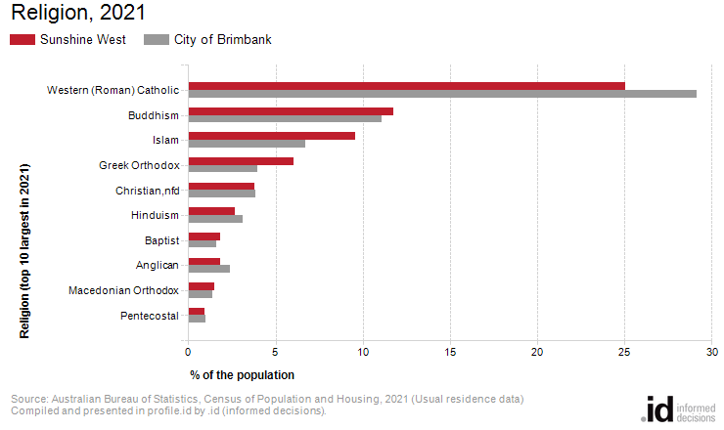
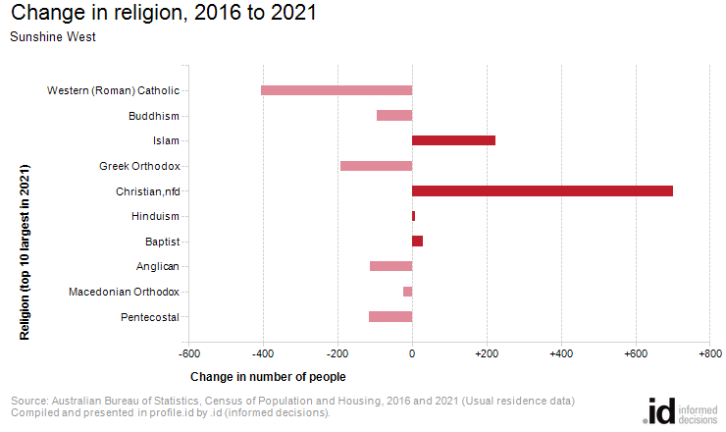
Analysis of the religious affiliation of the population of Sunshine West in 2021 compared to City of Brimbank shows that there was a lower proportion of people who professed a religion and a higher proportion who stated they had no religion.
Overall, 70.4% of the population nominated a religion, and 22.2% said they had no religion, compared with 71.3% and 21.1% respectively for City of Brimbank.
The largest single religion in Sunshine West was Western (Roman) Catholic, with 25.0% of the population or 4,643 people as adherents.
The major differences between the religious affiliation for the population of Sunshine West and City of Brimbank were:
- A larger percentage who nominated Islam (9.6% compared to 6.7%)
- A larger percentage who nominated Greek Orthodox (6.0% compared to 3.9%)
- A smaller percentage who nominated Western (Roman) Catholic (25.0% compared to 29.2%)
- A smaller percentage who nominated Sikhism (0.5% compared to 1.8%)
The largest changes in the religious affiliation of the population in Sunshine West between 2016 and 2021 were for those who nominated:
- Christian,nfd (+700 persons)
- Western (Roman) Catholic (-405 persons)
- Islam (+224 persons)
- Greek Orthodox (-192 persons)

