Blacktown City Council

Household income
Households form the common 'economic unit' in our society. Marsden Park – Shanes Park – Melonba's Household Income is one of the most important indicators of socio-economic status. With other data sources, such as Qualifications and Occupation, it helps to reveal the economic opportunities and socio-economic status of Marsden Park – Shanes Park – Melonba. It is important to note that income data is not necessarily a measure of wealth. For example, if an area has a large number of retirees this will produce a higher proportion of households with low income but the retirees may have large capital wealth. For this reason, household income should be viewed in conjunction with Age and Household Composition.
The incomes presented on this page are for the latest Census year only. For comparison of incomes over time, go to Household Income Quartiles.
Learn more about the characteristics of low-income households here.
Weekly household income
Marsden Park – Shanes Park – Melonba - Total households (Enumerated) | 2021
Weekly income | Number | % | Greater Sydney %
Neg/Nil Income | 39 | 0.8 | 2.1
$1 - $149 | 4 | 0.1 | 0.6
$150 - $299 | 9 | 0.2 | 1.1
$300 - $399 | 25 | 0.5 | 2.0
$400 - $499 | 76 | 1.6 | 4.3
$500 - $649 | 95 | 2.0 | 3.2
$650 - $799 | 104 | 2.2 | 4.6
$800 - $999 | 106 | 2.3 | 4.8
$1,000 - $1,249 | 164 | 3.5 | 5.9
$1,250 - $1,499 | 226 | 4.8 | 6.3
$1,500 - $1,749 | 207 | 4.4 | 5.2
$1,750 - $1,999 | 235 | 5.0 | 5.2
$2,000 - $2,499 | 681 | 14.5 | 11.4
$2,500 - $2,999 | 613 | 13.0 | 7.2
$3,000 - $3,499 | 621 | 13.2 | 7.0
$3,500 - $3,999 | 409 | 8.7 | 4.6
$4,000 - $4,499 | 229 | 4.9 | 2.8
$4,500 - $4,999 | 308 | 6.5 | 5.7
$5,000 - $5,999 | 180 | 3.8 | 4.1
$6,000 - $7,999 | 132 | 2.8 | 4.2
$8,000 or more | 25 | 0.5 | 1.7
Not stated | 221 | 4.7 | 5.8
Total households | 4,709 | 100.0 | 100.0
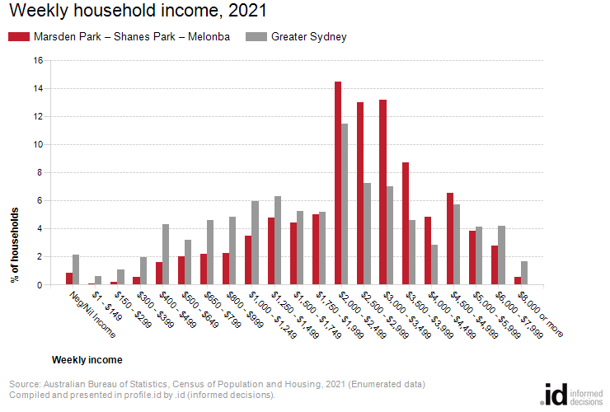
Analysis of household income levels in Marsden Park – Shanes Park – Melonba in 2021 compared to Greater Sydney shows that there was a larger proportion of high income households (those earning $3,000 per week or more) and a lower proportion of low income households (those earning less than $800 per week).
Overall, 40.4332% of the households earned a high income and 7.4749% were low income households, compared with 30.1063% and 17.9261% respectively for Greater Sydney.
The major differences between the household incomes of Marsden Park – Shanes Park – Melonba and Greater Sydney were:
- A larger percentage of households who earned $3,000 - $3,499 (13.2% compared to 7.0%)
- A larger percentage of households who earned $2,500 - $2,999 (13.0% compared to 7.2%)
- A larger percentage of households who earned $3,500 - $3,999 (8.7% compared to 4.6%)
- A larger percentage of households who earned $2,000 - $2,499 (14.5% compared to 11.4%)

