City of Greater Bendigo

Industry sector of employment
The City of Greater Bendigo's industry statistics identify the industry sectors in which the residents work (which may be within the residing area or elsewhere). This will be influenced by the skill base and socio-economic status of the residents as well as the industries and employment opportunities present in the region.
When viewed in conjunction with Residents Place of Work data and Method of Travel to Work, industry sector statistics provide insights into the relationship between the economic and residential role of the area.
Industry sector of employment
City of Greater Bendigo - Employed persons (Usual residence) | 2021 |  |  | 2016 |  |  | Change
Industry sector | Number | % | Regional VIC % | Number | % | Regional VIC % | 2016 to 2021
Agriculture, Forestry and Fishing | 1,295 | 2.3 | 7.2 | 1,292 | 2.7 | 7.7 | +3
Mining | 1,131 | 2.0 | 0.7 | 800 | 1.6 | 0.7 | +331
Manufacturing | 4,706 | 8.4 | 7.4 | 4,210 | 8.7 | 8.1 | +496
Electricity, Gas, Water and Waste Services | 704 | 1.3 | 1.4 | 620 | 1.3 | 1.5 | +84
Construction | 5,334 | 9.5 | 10.0 | 4,402 | 9.0 | 8.8 | +932
Wholesale trade | 982 | 1.7 | 2.2 | 857 | 1.8 | 2.2 | +125
Retail Trade | 5,543 | 9.8 | 9.5 | 5,572 | 11.4 | 10.6 | -29
Accommodation and Food Services | 3,834 | 6.8 | 6.6 | 3,382 | 6.9 | 7.0 | +452
Transport, Postal and Warehousing | 1,838 | 3.3 | 3.8 | 1,607 | 3.3 | 3.9 | +231
Information Media and Telecommunications | 515 | 0.9 | 0.8 | 564 | 1.2 | 1.0 | -49
Financial and Insurance Services | 1,902 | 3.4 | 1.9 | 1,872 | 3.8 | 1.9 | +30
Rental, Hiring and Real Estate Services | 553 | 1.0 | 1.0 | 509 | 1.0 | 1.1 | +44
Professional, Scientific and Technical Services | 2,393 | 4.3 | 4.5 | 2,010 | 4.1 | 4.2 | +383
Administrative and Support Services | 1,557 | 2.8 | 2.8 | 1,372 | 2.8 | 2.8 | +185
Public Administration and Safety | 3,500 | 6.2 | 6.3 | 2,884 | 5.9 | 6.1 | +616
Education and Training | 4,887 | 8.7 | 8.8 | 4,345 | 8.9 | 8.7 | +542
Health Care and Social Assistance | 10,759 | 19.1 | 16.2 | 8,117 | 16.7 | 14.3 | +2,642
Arts and Recreation Services | 802 | 1.4 | 1.5 | 690 | 1.4 | 1.5 | +112
Other Services | 2,101 | 3.7 | 3.6 | 1,835 | 3.8 | 3.6 | +266
Inadequately described or not stated | 1,969 | 3.5 | 3.9 | 1,726 | 3.5 | 4.0 | +243
Total employed persons aged 15+ | 56,305 | 100.0 | 100.0 | 48,666 | 100.0 | 100.0 | +7,639
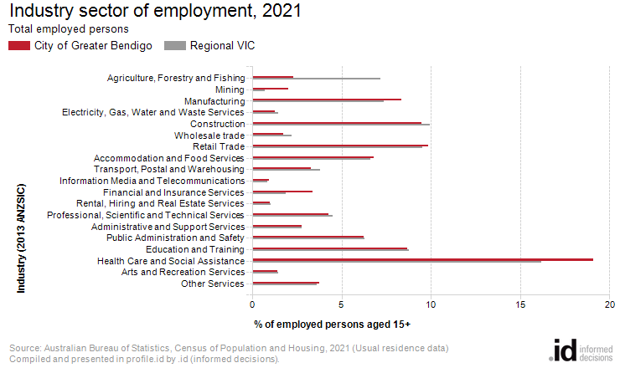
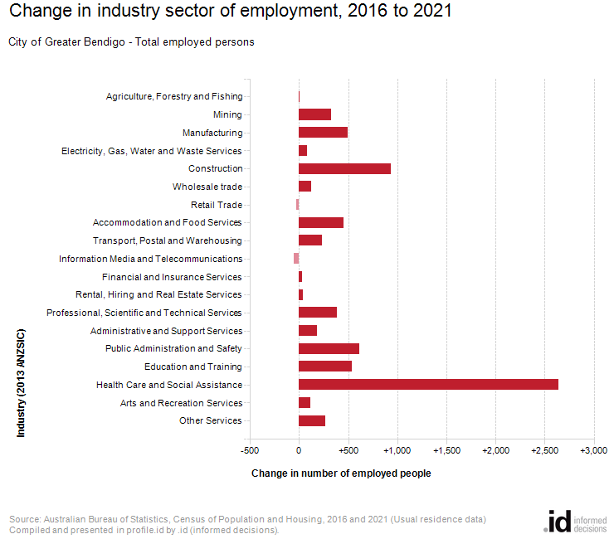
An analysis of the jobs held by the resident population in City of Greater Bendigo in 2021 shows the three most popular industry sectors were:
- Health Care and Social Assistance (10,759 people or 19.1%)
- Retail Trade (5,543 people or 9.8%)
- Construction (5,334 people or 9.5%)
In combination, these three industries employed 21,636 people in total or 38.4% of the total employed resident population.
In comparison, Regional VIC employed 16.2% in Health Care and Social Assistance; 9.5% in Retail Trade; and 10.0% in Construction.
The major differences between the jobs held by the population of the City of Greater Bendigo and Regional VIC were:
- A larger percentage of persons employed in health care and social assistance (19.1% compared to 16.2%)
- A larger percentage of persons employed in financial and insurance services (3.4% compared to 1.9%)
- A larger percentage of persons employed in mining (2.0% compared to 0.7%)
- A smaller percentage of persons employed in agriculture, forestry and fishing (2.3% compared to 7.2%)
The number of employed people in City of Greater Bendigo increased by 7,639 between 2016 and 2021.
The largest changes in the jobs held by the resident population between 2016 and 2021 in the City of Greater Bendigo were for those employed in:
- Health Care and Social Assistance (+2,642 persons)
- Construction (+932 persons)
- Public Administration and Safety (+616 persons)
- Education and Training (+542 persons)

