Australia

Number of cars per household
The ability of the population to access services and employment is strongly influenced by access to transport. The number of motor vehicles per household in Australia quantifies access to private transport and will be influenced by Age Structure and Household Type, which determine the number of adults present; access to Public Transport; distance to shops, services, employment and education; and Household Income. Depending on these factors, car ownership can be seen as a measure of advantage or disadvantage, or a neutral socio-economic measure, which impacts on the environment and quality of life.
Car ownership
Australia - Households (Enumerated) | 2021 |  |  | 2016 |  |  | Change
Number of cars | Number | % | Greater Capital Cities % | Number | % | Greater Capital Cities % | 2016 to 2021
No motor vehicles | 691,886 | 7.1 | 8.1 | 643,304 | 7.3 | 8.2 | +48,582
1 motor vehicle | 3,438,319 | 35.1 | 36.0 | 2,945,022 | 33.2 | 33.7 | +493,297
2 motor vehicles | 3,395,106 | 34.6 | 34.4 | 3,025,454 | 34.1 | 34.1 | +369,652
3 or more motor vehicles | 1,754,876 | 17.9 | 16.8 | 1,505,374 | 17.0 | 16.4 | +249,502
Not stated | 528,207 | 5.4 | 4.7 | 742,467 | 8.4 | 7.6 | -214,260
Total households | 9,808,394 | 100.0 | 100.0 | 8,861,621 | 100.0 | 100.0 | +946,773
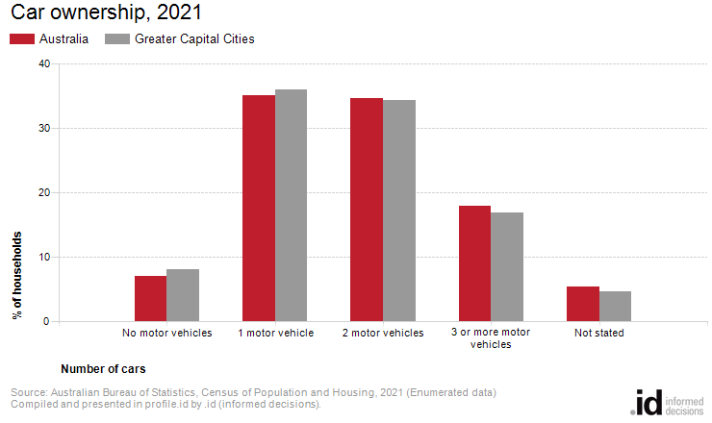
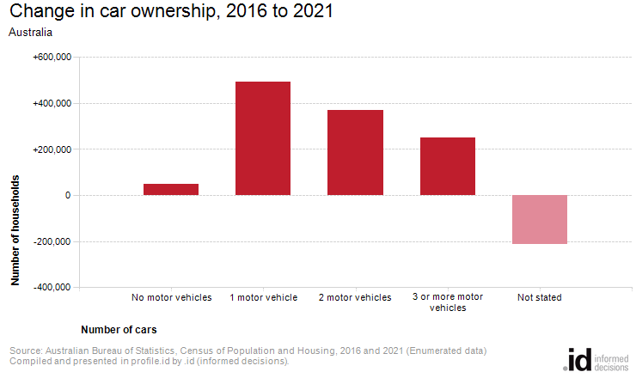
Analysis of the car ownership of the households in Australia in 2021 compared to Greater Capital Cities shows that 87.6% of the households owned at least one car, while 7.1% did not, compared with 87.2% and 8.1% respectively in Greater Capital Cities.
Of those that owned at least one vehicle, there was a smaller proportion who owned just one car; a similar proportion who owned two cars; and a larger proportion who owned three cars or more.
Overall, 35.1% of the households owned one car; 34.6% owned two cars; and 17.9% owned three cars or more, compared with 36.0%; 34.4% and 16.8% respectively for Greater Capital Cities.
The largest changes in the household car ownership in Australia between 2016 and 2021 were:
- 1 motor vehicle (+493,297 households)
- 2 motor vehicles (+369,652 households)
- 3 or more motor vehicles (+249,502 households)
- No motor vehicles (+48,582 households)

